Home Learning Through Play
Games supporting combined learning opportunities
Jigsaws | Lego | Play-doh
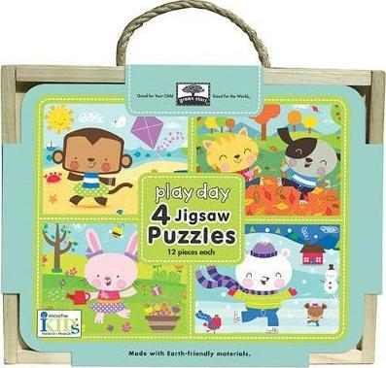 |  | 
- Visual patterns  - Fine motor skills | - Imagination  - Fine motor skills  - Following instructions  - Communication | - Imagination  - Fine motor skills
Ker-Plunk | Connect 4 | Uno
 | 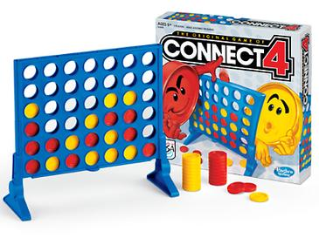 | 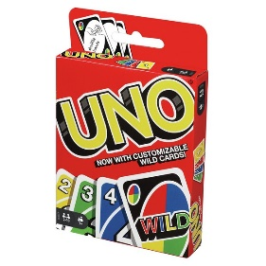
- Turn taking  - Fine motor skills  - Problem solving | - Turn taking  - Patterns  - Strategies  - Sequencing | - Turn taking  - Visual skills  - Sequencing
Chess | Draughts | Rummikub
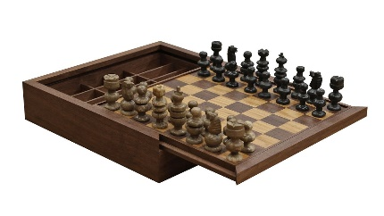 | 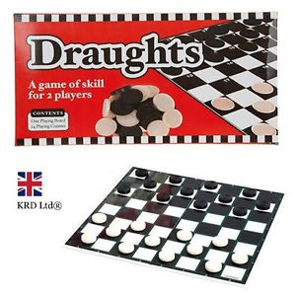 | 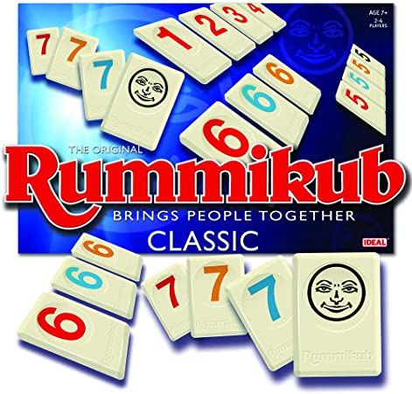
- Mathematical strategy  - Social skills  - Communication  - Memory skills  - Following rules | - Mathematical strategy  - Following rules  - Communication  - Memory skills | - Social skills  - Turn taking  - Number and colour patterns  - Sequencing  - Problem solving
Frustration | Bingo | Yahtzee
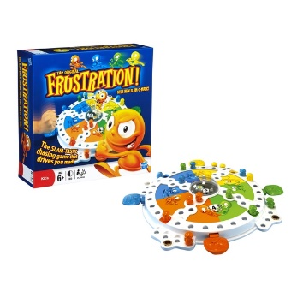 | 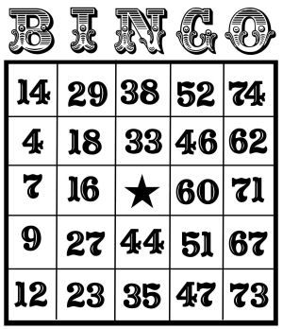 | 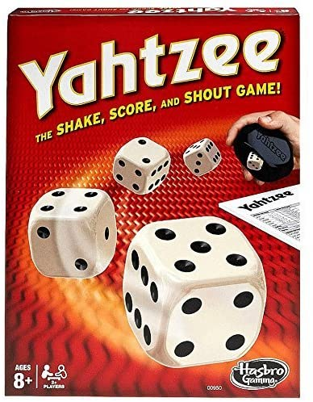
- Turn taking  - Fine motor skills  - Counting  - Strategy | - Focus  - Concentration  - Number recognition | - Turn taking  - Strategy  - Recording  - Addition  - Number bonds
Dominos | Monopoly | Jenga
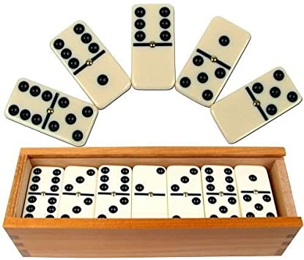 | 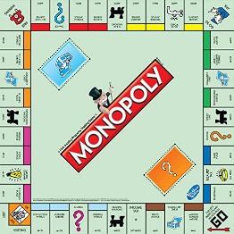 | 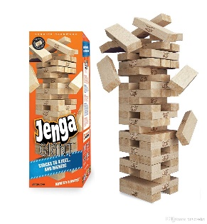
- Turn taking  - Number recognition  - Communication  - Following rules | - Turn taking  - Communication  - Counting  - Strategy  - Money management | - Social skills  - Turn taking  - Focus  - Care and attention  - Problem solving
Cluedo | Card Games | Snakes and Ladders
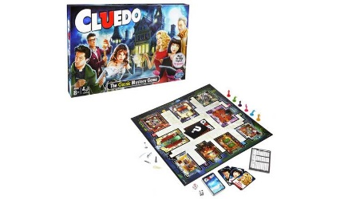 |  | 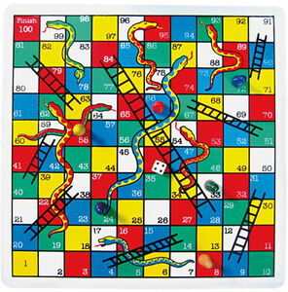
- Turn taking  - Problem Solving  - Communication  - Strategy | - Number recognition  - Patterns and sequencing  - Memory | - Turn taking  - Counting  - Number recognition

