Online Resources ALN pupils
Resource Name | Website | Focus | Access
General Resources
  Supporting Children with  Learning Disability/ASD  Coping with COVID-19 Isolation |  | Cardiff and Vale Health Board.  This Booklet was put together by colleagues in Community Family Psychology, Neurodevelopmental Team and Children’s Occupational Therapy (20th March 2020) | Download PDF inserted
5 Fun Things to Try Each Day   |  | 5 fun things to try every day whilst at home | Inserted document here
Sensory App House Ltd | Website: https://www.sensoryapphouse.com/ | A range of apps are available for pupils with Profound and Multiple Learning Difficulties (PMLD) or Severe Learning Difficulties (SLD). All are interactive and many do not require significant coordination abilities. | Free
For Early years  Idea Machine Story Time Show  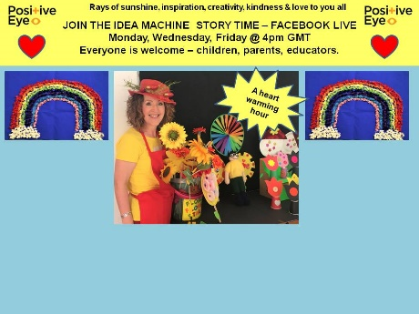 | Live storytelling Monday, Wednesday and Friday at 4pm  The link to watch the show live is: https://www.facebook.com/PositiveEyeIdeaMachine  Saved story sessions on website They can be viewed on YouTube from these pages, chapter by chapter and they include the craft make for each show.  https://www.positiveeye.co.uk/our-services-2/bespoke-courses/activity-shares-for-families-covid19/ | Fun characters with craft activities to do together | Free
Games to try! | https://education.minecraft.net  Multiplayer mode, new Minecraft: EE resources and training opportunities for teachers available for distance learning.  Teachers and Learners in maintained schools in Wales can download and install Minecraft:EE for free and log in using their Hwb account details.  Many teachers have already started using Minecraft:EE with their learners and the Minecraft:EE team have published a new remote learning kit to keep learners engaged when learning from home.  In addition to completing individual projects, learners can access ‘Multiplayer’ mode, allowing them to collaborate with their friends on different projects.  Details for setting up multiplayer games can be found here.  Multiplayer mode will allow learners to participate in the new Minecraft Education Challenge, which is to ‘Build a Better World’. The challenge provides a long-term project for learners to work on over several weeks.  Please continue to check the Hwb Distance Learning page for updates, ideas and links to support learning. | An online game to promote problem solving skills | Free
SENict Activities   | Website: https://www.ianbean.co.uk/senict-members-resource-portal | Downloadable activities aimed particularly at Profound and Multiple Learning Difficulties (PMLD) and Severe Learning Difficulties (SLD) learners. | Registration not required
Inclusive Teach   | Website: https://inclusiveteach.com/free-printable-sen-teaching-resources/ | Downloadable teaching resources to support pupils with SEND. | Registration not required
Speech and Language Kids   | Website: https://www.speechandlanguagekids.com/free-speech-language-resources/ | A range of education and therapy resources for speech and language problems. A podcast is also available on iTunes for verbal and non-verbal children. | Registration not required
Visuals2Go  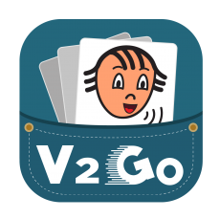 | Website: https://www.visuals2go.com/ | An all-in-one app created to support people with communication and learning difficulties. For verbal and non-verbal learners. | Free
 |  | Resource to create visual schedules | Free
  https://www.pictoselector.eu/
The Day newsletter  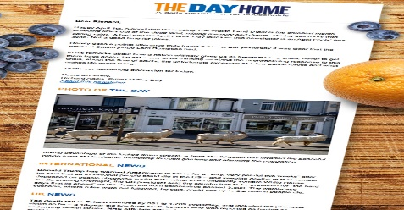 | Website: https://theday.co.uk/subscriptions/the-day-home | Key stages: key stage 1 and key stage 2  A daily newsletter for parents and carers at home with children, helping to enrich learning with real-world knowledge and skills | Registration is required
 |  | Sensory play ideas | Free
  https://www.learning4kids.net/list-of-sensory-play-ideas/
 |  | Online English games to play | Free
  http://www.funenglishgames./
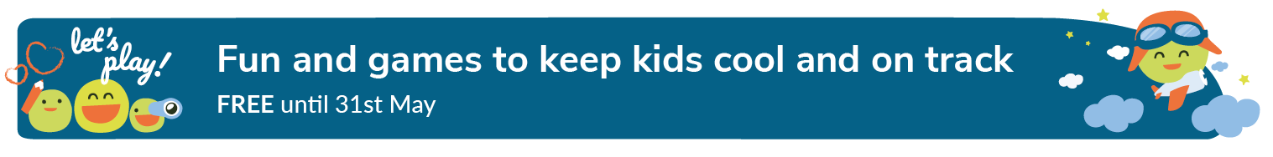easyPeasy | https://www.easypeasyapp.com/parents  Resources: App | App for language and communication games This app is currently free with limited access for parents and staff in early years | You need to register to get the app to try free until 31.5.20
 | https://www.wordshark.co.uk/about-us/ | Wordshark provides a fun and effective games-based solution for students learning to spell and read. | Ask your school if they have this online edition of Wordshark and if so, will your child have access to the program
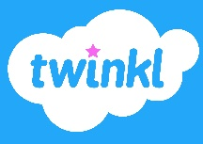 | https://www.twinkl.co.uk/ | Range of materials and resources to support literacy and numeracy, as well as creative learning, for all ages | Free accounts available at present
 | https://www.bbc.co.uk/bitesize | All national curriculum subjects, lessons running on a weekly timetable | Free
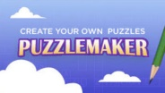 | http://puzzlemaker.discoveryeducation.com/ | Puzzlemaker for a range of different subject areas | Free
 | https://www.everyschool.co.uk/ | Range of resources for different subjects by Year Group | Free
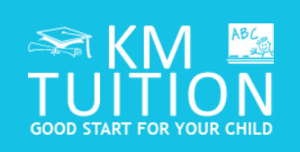 | http://www.kmtuition.co.uk/index.html | Maths and English resources for a range of Year Groups, focus on skill development | Free
 | https://www.open.edu/openlearn/free-courses/full-catalogue | Resources in a range of curriculum areas for children over 13 | Free
Purple Mash  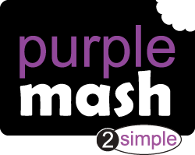 | Website: https://2simple.com/purple-mash/ | Key stages: early years foundation stage to key stage 2 Free during the school closure period. Each week, a selection of daily activities is produced on different subjects, including comprehension and grammar. | Registration is required
English as an Additional Language (EAL/WAL)  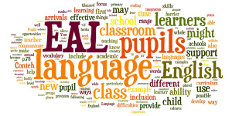 | British Council Learn English for Kids  And this one is for Teens  British Council Learn English Teens | This a link to the British council Learn English for Kids which also good and interactive | Free
 | https://www.topmarks.co.uk/ | Range of resources for different age groups and subjects | Free
History
 | https://www.squaducation.com/ | History through the ages – linked to the National Curriculum | Two week subscription free
Languages
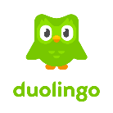 | https://www.duolingo.com/learn | Support to learn a range of languages | Free
Reading
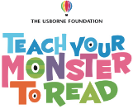 | https://www.teachyourmonstertoread.com | Games to support learning how to read | Sign up - free
Audible   | Website: https://stories.audible.com/start-listen | Key stages: key stage 3 and key stage 4  Description: all children’s audiobooks are available for free while schools are closed.  Registration: not required | Registrationnot required
Seneca | Website: https://app.senecalearning.com/courses?Price=Free&Age+Group=GCSE&Subject=English+Language | Key stages: key stage 4  Description: a range of downloadable resources covering the GCSE curriculum, categorised by examination board.  Registration: not required | Registration not required
English Mastery   | Website: https://www.englishmastery.org/ | Key stages: key stage 3  Downloadable resource books providing 12 weeks of activities covering writing and poetry. | Registration not required
Elevenses with the World of David Walliams  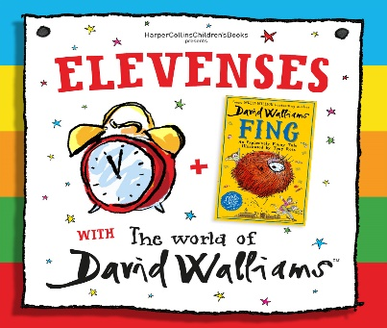 | Website: https://www.worldofdavidwalliams.com/elevenses/ | Key stage 2  Description: one free audio book reading is available to listen to every day. | Registration not required
Storytime with Nick  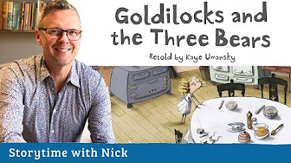 | Website: https://www.youtube.com/playlist?list=PLDe74j1F52zQ51fqNpKV07E71knNl8HFn | Key stages: early years foundation stage and key stage 1  Description: films of well-loved stories read by Nick Cannon, a trained actor, teacher and trainer available Monday, Wednesday and Friday at 2pm | Registrationnot required
 | https://home.oxfordowl.co.uk/ | Reading materials for 3 – 11 year olds, free ebook library | Free
Maths
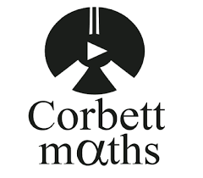 | https://corbettmaths.com/ | Maths for a range of ages, including GCSE | Free
 | https://www.prodigygame.com/ | Maths activities for primary school children | Sign up - Free
 | https://www.doodlemaths.com/ | Maths activities and quizzes | Free 7 day Trial
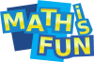 | https://www.mathsisfun.com/ | Primary resources for Maths | Free
 | https://www.mathschase.com/ | Maths games and activities for Reception to Year 4 | Free
Science
 | http://www.schoolscience.co.uk/home | Science resources and activities from primary to A Level | Free
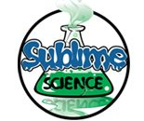 | https://www.sublimescience.com/free-science-experiments/ | Science experiment ideas for a range of ages | Free
 | https://www.bbc.co.uk/teach/terrific-scientific | Science investigations and resources | Free
Coding
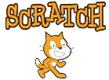 | https://scratch.mit.edu/ | Interactive programming activities | Free
 |  | Science fun! | Free
  http://www.sciencekids.co.nz/
Arts and Crafts
 | https://www.homeschooling-ideas.com/kids-craft-ideas.html | Ideas for art and craft projects | Free
 | https://www.redtedart.com/ | A range of ideas for craft based learning | Free
 | http://krokotak.com/ | Creative ideas to support learning | Free
Exercise
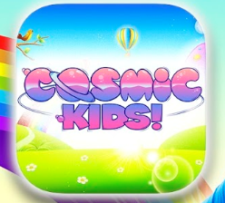 | https://www.youtube.com/user/CosmicKidsYoga | Yoga for children | Free
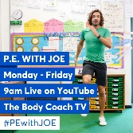 | https://www.youtube.com/channel/UCAxW1XT0iEJo0TYlRfn6rYQ | PE sessions at 9am each day - live | Free
Disney 10 Minute Shakeups  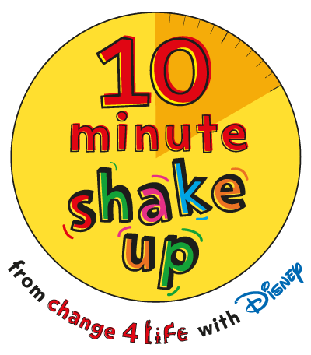 | Website: https://www.nhs.uk/10-minute-shake-up/shake-ups | Description: 10-minute activities based on Disney films that count towards a child’s 60 active minutes per day. | Registrationnot required
Super Movers  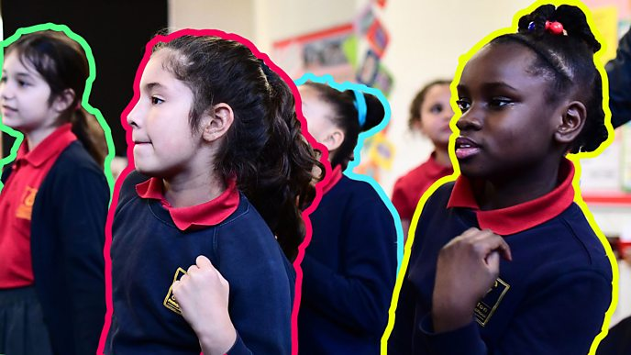 | Website: https://www.bbc.co.uk/teach/supermovers | Key stages: key stage 1 and key stage 2  Videos which help children move while they learn. They support curriculum subjects, including maths and English. | Registration not required
Fitness Blender   | Website: https://www.fitnessblender.com/ | Key stages: key stage 3 to key stage 5  Description: videos featuring a range of exercises and workouts. You can choose exercises by: degree of difficulty, type, gender and whether equipment is needed or not | Registration not required
Covid Resource  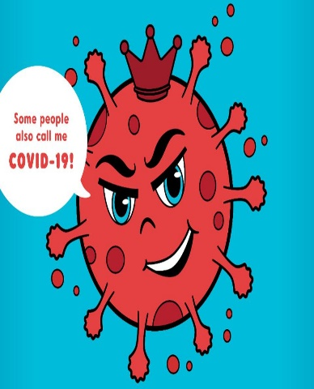 | https://www.mindheart.co/descargables | A short book in many languages to support and reassure children, under the age of 7, regarding the COVID-19.  This book is an invitation for families to discuss the full range of emotions arising from the current situation. It is important to point out that this resource does not seek to be a source of scientific information, but rather a tool based on fantasy. The recomendation is to print this material so children can draw on it. Remember that emotions are processed through repetitive play and stories read multiple times
Covid-Bilingual resource | https://nosycrow.com/blog/released-today-free-information-book-explaining-coronavirus-children-illustrated-gruffalo-illustrator-axel-scheffler/  Cymraeg:  https://atebol-siop.com/coronafeirws-llyfr-i-blant.html | This children’s book about Coronvirus is available in Welsh and in English, it’s free and it’s illustrated by Axl Scheffler (who does the illustrations for Julia Donaldson books)
Anna Freud National Centre for Children and Families   | Website: https://www.annafreud.org/media/11160/supporting-schools-and-colleges.pdf | Description: a downloadable guide to supporting the mental health and wellbeing of pupils and students during periods of disruption. | Free
BPS  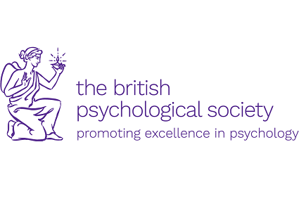 | Website: https://www.bps.org.uk/news-and-blogs | Key stages: key stage 3 to key stage 5  Description: advice on dealing with school closures and talking to children about COVID-19.  Registration: not required | Registration not required
Rise Above   | Website: https://riseabove.org.uk/topic/my-mind/ | Key stages: key stage 3 to key stage 5  Description: videos with tips on gaining confidence, dealing with anxiety and coping strategies from other young people. | Registration not required
Resources of  the Week  From the Gwent Attachment Service &  Gwent Community Psychology Service ABUHB   | Interactive Google Drive Resource Directory | An interactive directory of all  the COVID-19 resources that have been have collected and reviewed by Gwent Attachment and Community Psychology services

